

Preliminary HIV Analysis

## Number of deaths of HIV for the period 2003 to 2014

#### *Overall*

In order to explore the trend in deaths of HIV in Puerto Rico, we conducted a crude analysis using the data from the HIV Surveillance System that contain the deceases for the period 2003 to 2014. The trend in HIV deaths can be seeing in Figure 1:

Figure : Trend in Number of HIV Deaths Overall

Figure 1 shows a decreasing trend in the number of deaths for about 4.6% (10.0% in 2003 compared with 5.6% in 2014) in Puerto Rico. We explored the number of deaths using the JoinPoint Software from SEER. The results were:

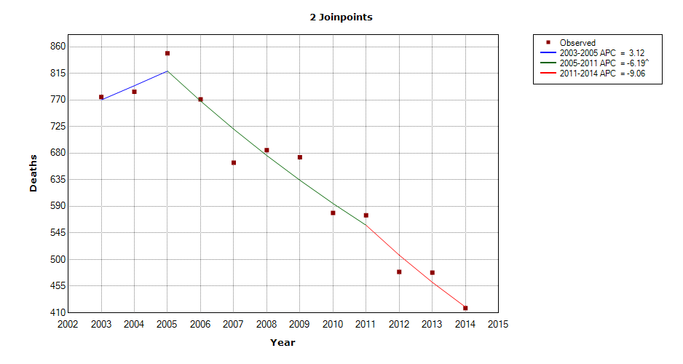

Figure : Number of HIV Deahts Overall (JoinPoint)

According to the Join Point Software, a statistical significant decreasing trend in number of HIV deaths is observed for the period 2005-2011 (Figure 2). We proceeded to calculate the percent change for different periods using a mathematical model from CDC. The formula is as follows:

$$Pc= \frac{\left|{\#Deaths}_{x} - {\#Deaths}_{x-1}\right|}{{\#Deaths}_{x-1}}$$

where “**x**” represents the latest year in the period of interest.

The calculated percent changes are in the following table:

Table : Overall Percent Changes

|  |  |
| --- | --- |
| Years | Percent Change (%) |
| 2003-2005 | 9.55 |
| 2006-2008 | 11.15 |
| 2009-2011 | 14.56 |
| 2012-2014 | 12.73 |

It is **important** to point out that these percent changes in Table 1 are in absolute values which mean that they do not specify the direction of the changes, only their magnitude. In order to verify whether there was a statistical significant difference in the percent changes across the period, we used a Poisson model:

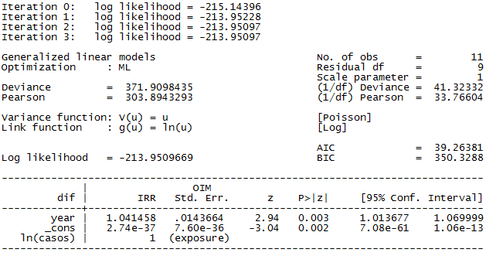

Figure 3: Poisson Model for Overall Percent Change

The Poisson model (Figure 3) shows a statistical significant difference between the percent changes for the period of study, which goes according with the result from JoinPoint Software (p-value = 0.003). The results might explain the discrepancy (about 30%) in the number of HIV deaths predicted by CDC in 2013. It could be a normal behavior due the fact that the life expectancy keeps increasing with the development of new and better treatments, or it could be something else. In order to clarify this matter, a deeper analysis is needed.

One of our hypothesis is that since an increase in HIV cases among Men who have Sex with Men (MSM) have occurred recently, higher income and better access to services among this population when compared to injection drug users (IDU) could be changing the burden of the disease and subsequently reflecting a decreasing trend in HIV deaths in Puerto Rico. Hence, we performed a brief exploration within these two groups.

#### *Men who have Sex with Men (MSM) vs Injection Drug Users (IDU)*

To have a better understanding of what might be happening within these two groups, first we graph the number of deaths stratified by MSM and IDU:

Figure : Trend in Number of HIV Deaths by MSM & IDU

Figure 4 shows a decreasing trend in HIV in Puerto Rico for both groups. In the IDU group, we can see a decrease of almost 7% which might explain the reason why the overall trend is also decreasing. The results from JoinPoint were:

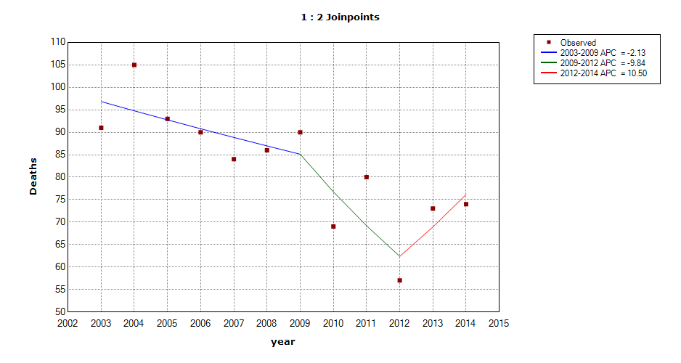

Figure : Number of HIV Deaths for MSM (JoinPoint)

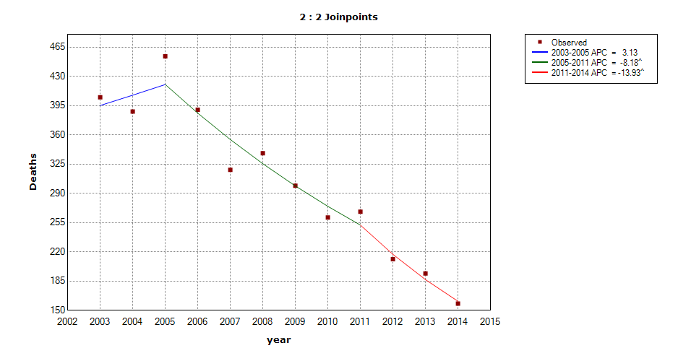

Figure : Number of HIV Deaths for IDU (JoinPoint)

According to the JoinPoint results, for the MSM group there was not a statistical significant reduction in the number of HIV deaths (Figure 5), while in the IDU group a statistical significant reduction was observed for the period 2005-2011 (p-value < 0.05) (Figure 6). We ran a Poisson model to evaluate significant in the number of deaths across the period of study for both groups separately.

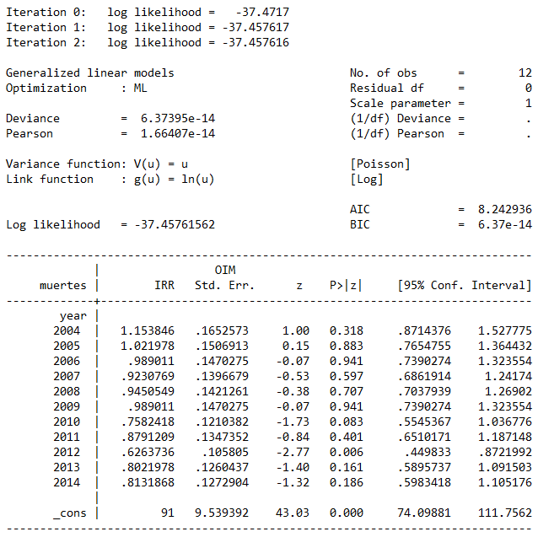

Figure 7: Poisson Model for Number of HIV Deaths for MSM

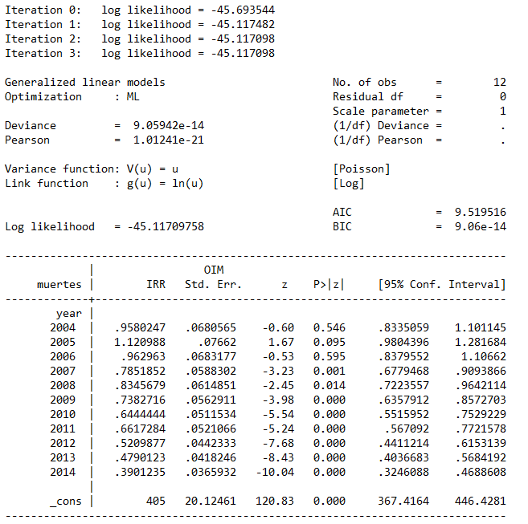

Figure 8: Poisson Model for Number of HIV Deaths for IDU

Figure 7 shows a reduction in number of deaths in the MSM group of almost 19% in 2014 when compared to 2003, although no statistical significant difference was observed (p-value > 0.10). On the other hand, Figure 8 shows a reduction in number of deaths in the IDU group of almost 41% in 2014 when compared to 2003. This reduction was statistically significant (p-value < 0.001). In other words, the number of deaths for the MSM group keep a constant reduction. That is not the case for the IDU group which was observed a marked reduction in the number of death for the study period. These results complement the ones provided by JoinPoint Software. The percent chances for both groups are shown in Table 2:Table 1

Table : Percent Changes by Mode of Transmission

|  |  |  |
| --- | --- | --- |
| Year | Percent Change MSM (%) | Percent Change IDU (%) |
| 2003-2005 | 2.20 | 12.10 |
| 2006-2008 | 4.44 | 13.33 |
| 2009-2011 | 11.11 | 10.37 |
| 2012-2014 | 29.82 | 25.12 |

To try to answer our hypothesis, we verified if the number of new cases vary across the study period. Table 3 shows the number of new HIV cases among MSM and IDU:

Table : Number of new cases among MSM and IDU

|  |  |  |
| --- | --- | --- |
| Year | MSM | IDU |
| 2003 | 127 | 267 |
| 2004 | 143 | 222 |
| 2005 | 173 | 240 |
| 2006 | 172 | 205 |
| 2007 | 190 | 162 |
| 2008 | 214 | 185 |
| 2009 | 224 | 126 |
| 2010 | 240 | 102 |
| 2011 | 244 | 90 |
| 2012 | 271 | 85 |
| 2013 | 270 | 88 |
| 2014 | 257 | 60 |

And the respective graphic:

Figure 9: Trend in Number of New HIV Cases by MSM & IDU

Figure 9 shows an increasing trend in new cases among MSM across the study period. On the other hand, a decreasing trend is observed for the IDU group. In order to verify if these trends are statistical significant, we used a Poisson model for each group.

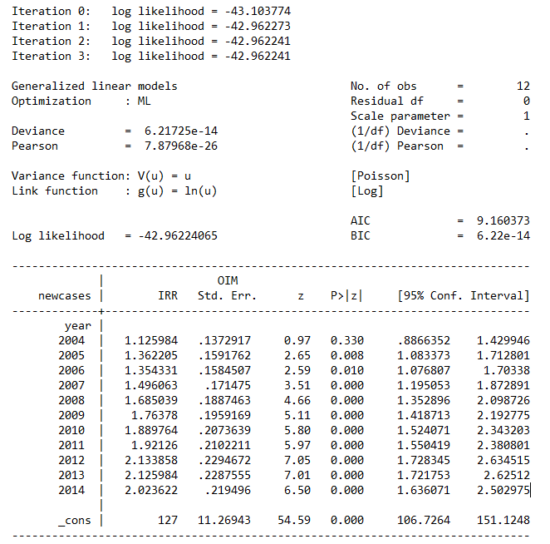

Figure 10: Poisson Model for HIV New Cases for MSM

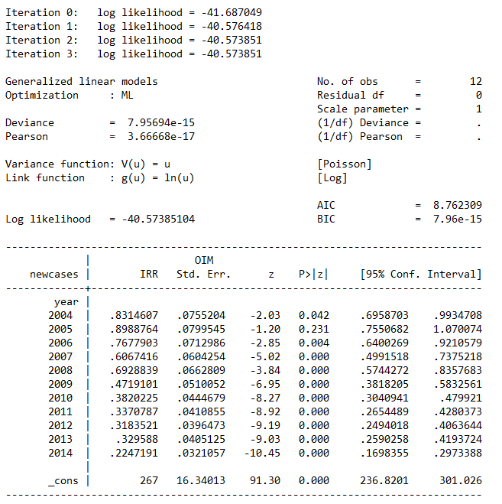

Figure 11: Poisson Model for HIV New Cases for IDU

Figure 10 shows statistical significant increase in number of new HIV cases for MSM of about 102% in 2014 when compared to 2003 (p-value < 0.001). Nevertheless, a statistical significant decrease of about 88% in number of new HIV cases for IDU in 2014 when compared to 2003 has been observed (p-value < 0.001) (Figure 11). These results support our hypothesis which try to explain the discrepancy of 30% in the number of deaths reported in the Puerto Rico Surveillance System when compared with the CDC mathematical model. It appear that a change in the burden of the decease has occurred. We can clearly observe an increasing trend in conjunction with a decreasing trend of HIV new cases for the MSM and IDU groups respectively. Further investigation using more sophisticated analysis will be needed in order to have a better insight of the behavior of HIV mortality in Puerto Rico.